|  |  |  |  |  |  |
| --- | --- | --- | --- | --- | --- |
| Date | December 14, 2022 | | | Tester Name | Syed Shahabuddin |
| Environment | Penfax - Test | | | Login used |  |
| Operating System | Select OS | Version: | Update: | | |
| Software Used | Select Software | Version: | Update: | | |
| Select Software | Version: | Update: | | |
| Release version | 22.3.0 | | | | |
| Title | E 23.04 & 23.04b | | | | |
| Test Type | Regression | | | | |
| Test Scenario | Process Tax Exemption Indexation Batch | | | | |
|  |  | | | | |
| Expected Results | JEA Instructions:   * Add the "Tax Exemption Indexation" batch through Batch Processes * Enter the tax year for the new instructions" * Verify that the batch ran successfully * Verify that for the member's found in Step 1's precondition, the tax instructions were updated/added correctly as per the new year and the exemptions on the previous tax instruction   Confirm 5 members who are in VPB that require tax updates, that it updated correctly (in tax instructions and in benefit recipient and that all the details match).   * Test at least one member with “additional amount to be deducted” in tax instructions. * Test at least one member with claim code 0 in tax instructions * Find a VPB member not from the tax batch list (from the app or member search) to confirm their instruction was updated correctly   Note: *If any VPB members have a TD1 type of “basic” and not “advanced” there isn’t supposed to be a new tax instruction created. If any members do not have funds in their investment account, a new tax instruction will not be created. Any other member should have a new tax instruction when this batch is ran.*  23.04b   * Test members with more than one plan & ensure the tax instructions get attributed to the proper plan in benefit recipient * Confirm that a member without a retirement/income in benefit recipient still has a new tax instruction generated & isn’t missed so that when they take their first payment (set up online or in office) then the correct year’s tax rates are attributed to the payment. | | | | |
| Pass/Fail | Pass | | | JIRA# | N/A |

Added TD1 claim basic personal amount for Federal & SK (effective dated Dec 14, 2022)

Ran Tax Indexation Batch – ran succesfully

Not producing a tax instruction in the following situations:

1. Claim Code 0 (SID: 243122, 237701)
2. No Retirement/Income in Benefit Recipient (there is a Benefit Recipient for a one-time payment) (SID: 274415)
3. No Benefit Recipient (SID: 274371)

Test Dec 14

STEP 1:

Update TD1 instructions then run the tax indexation batch.

To process:

Go to Plan Rules/TD1 Claim amounts

Choose the TD1 jurisdiction (update at minimum SK and federal)

Clicked add on the top section

Clicked edit on the bottom section and ensured both claim code 1/basic personal amount numbers matched (choose a random number for it to update to).

Alberta:

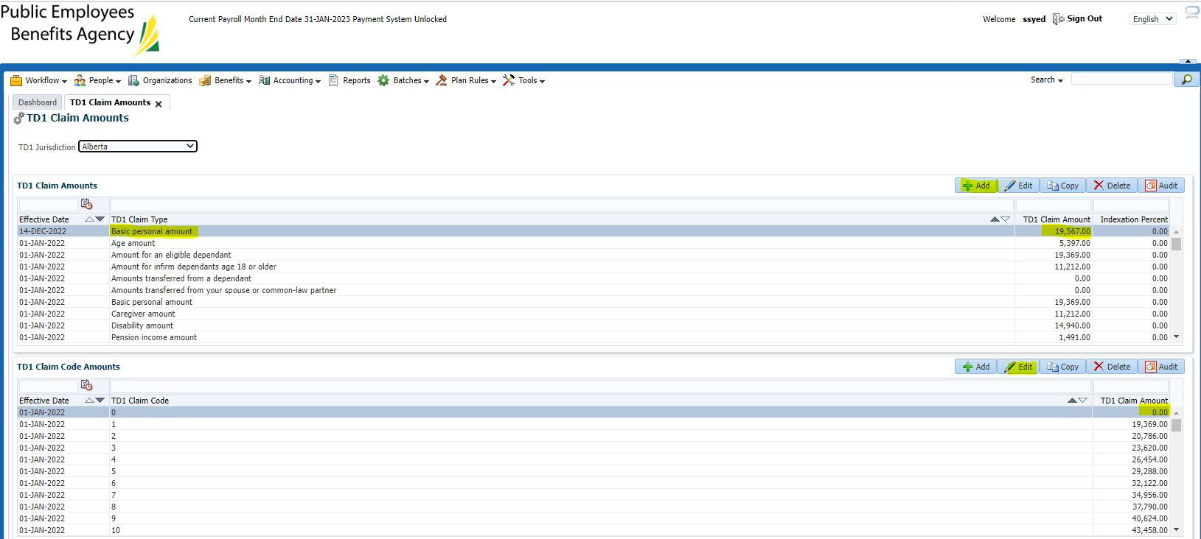

Saskatchewan:

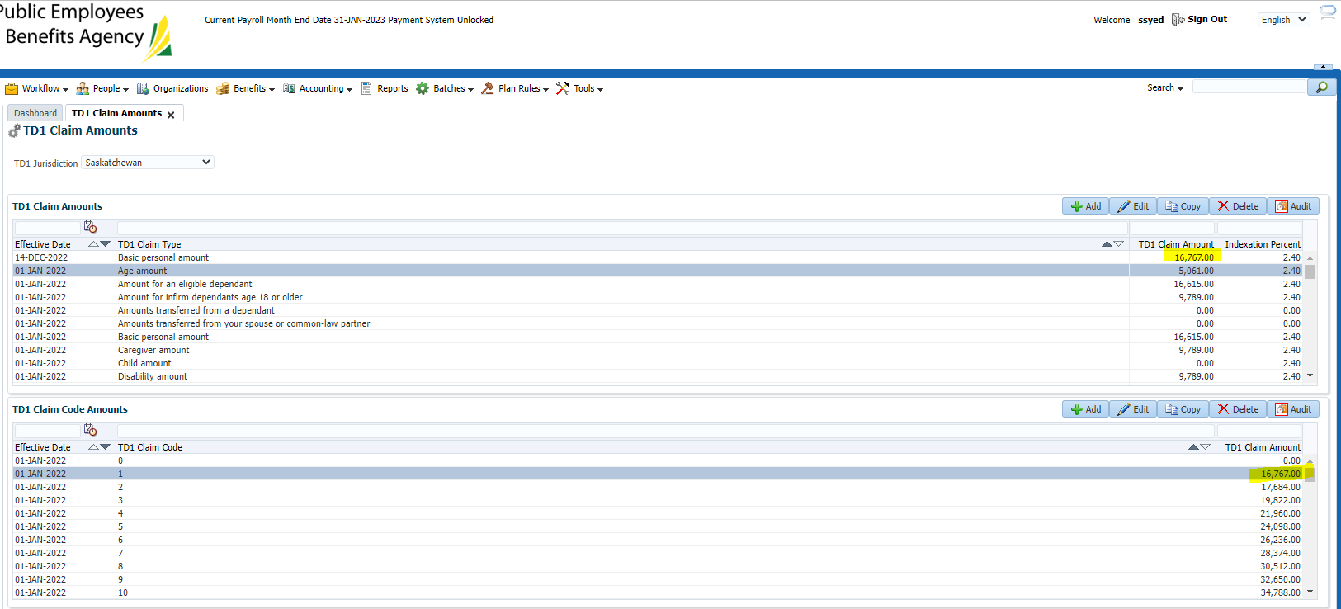

Federal (updated basic personal amounts):

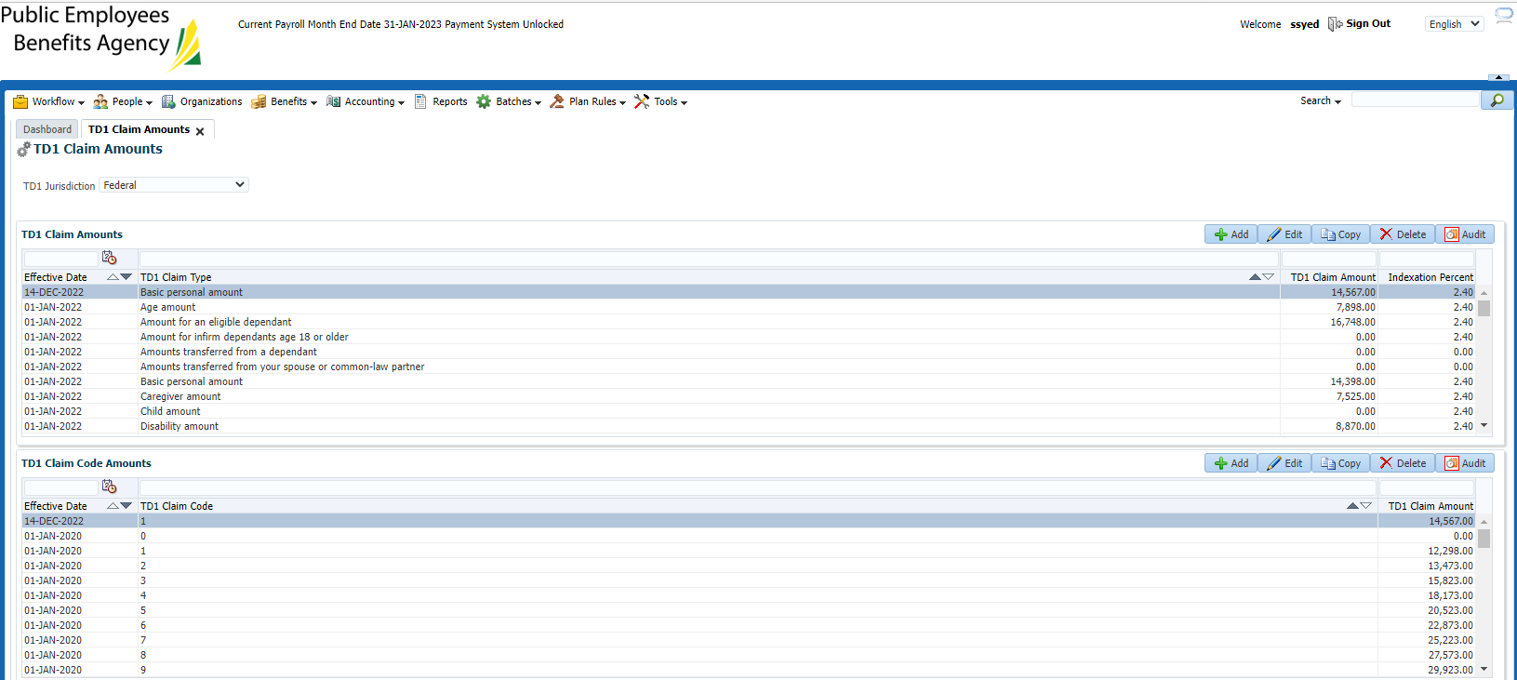

STEP 2:

Run Tax Indexation Batch:

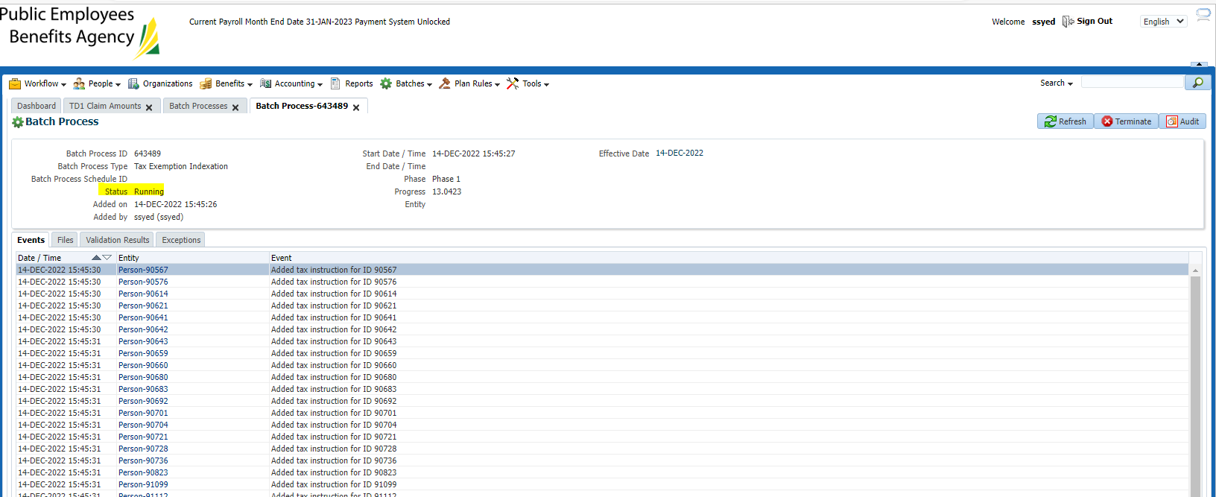

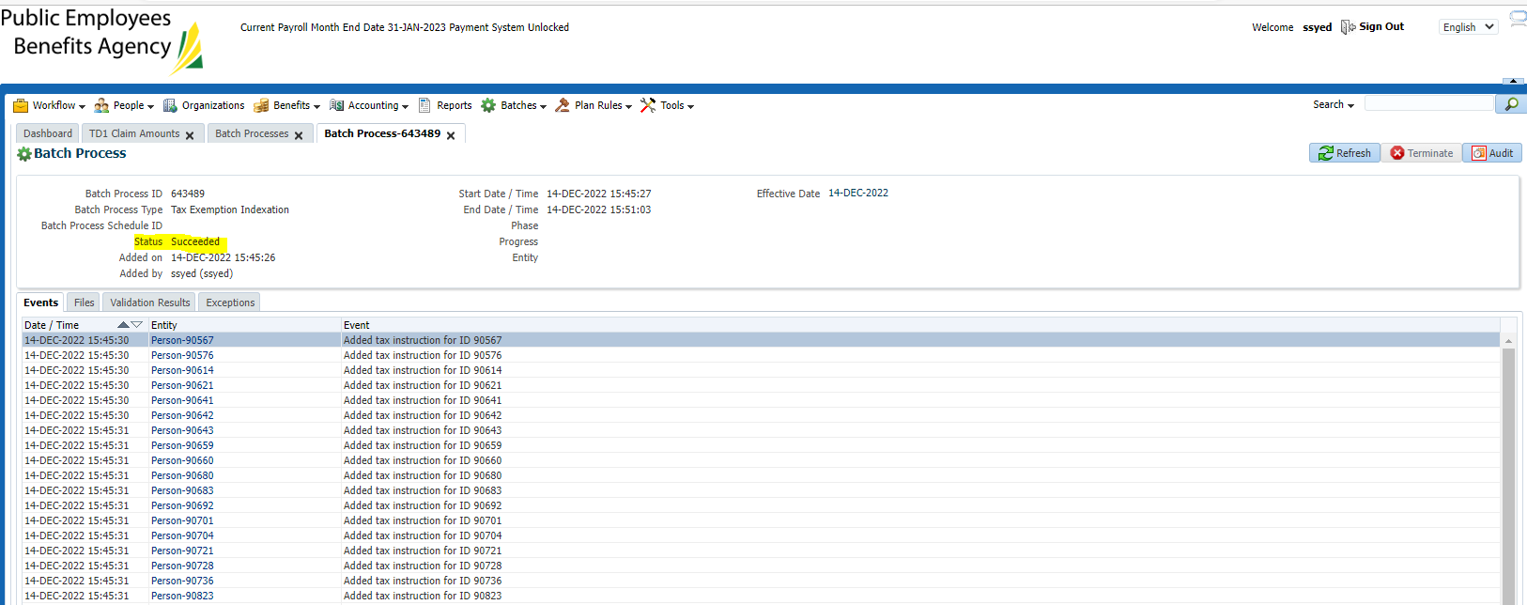

*the batch includes all PENFAX tax instructions (not just PEPP), found PEPP members in the list

SID 238514

Before:

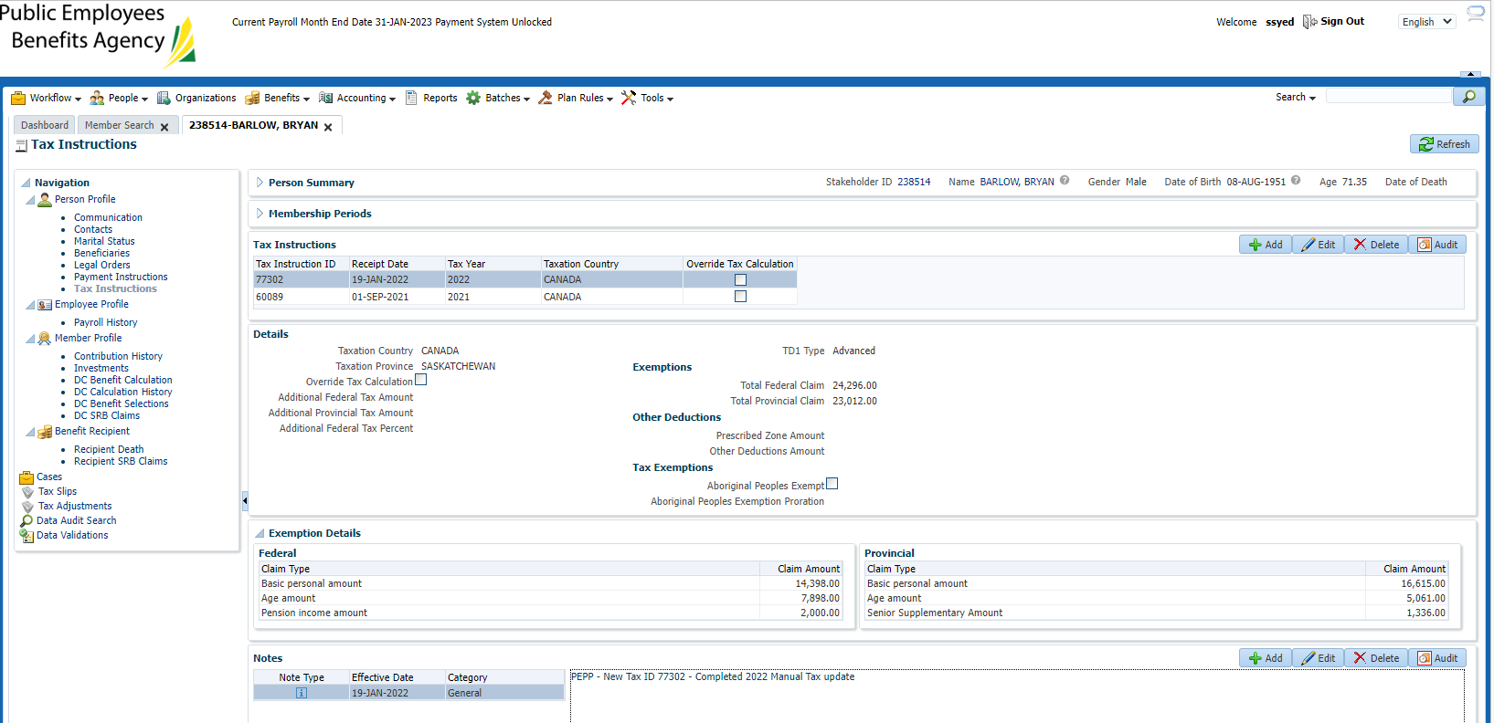

After:

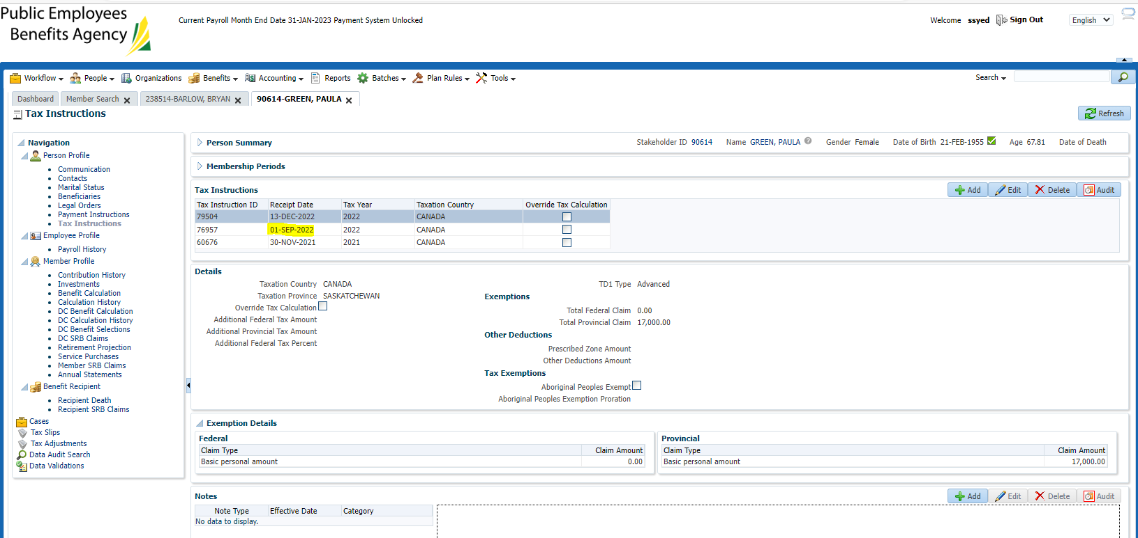

TD1 amounts were updated as previously updated in the TD1 claim amounts screen.

Benefit recipient also reflects the change:

Selected the retirement event type, income benefit type, and then clicked on the income benefit tab and looked at the tax instruction section.

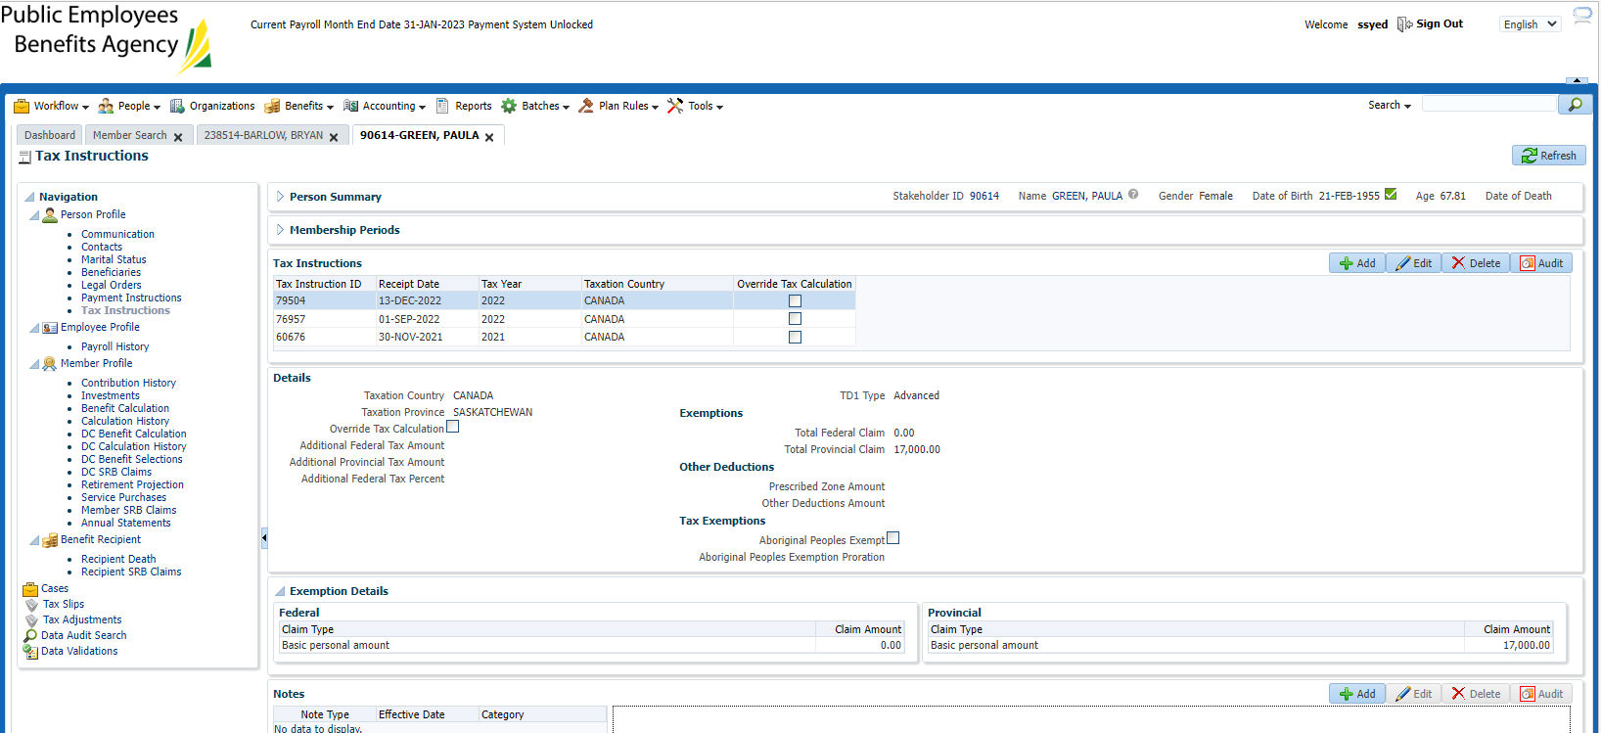

SID: 90614 – claim code not 0

Before:

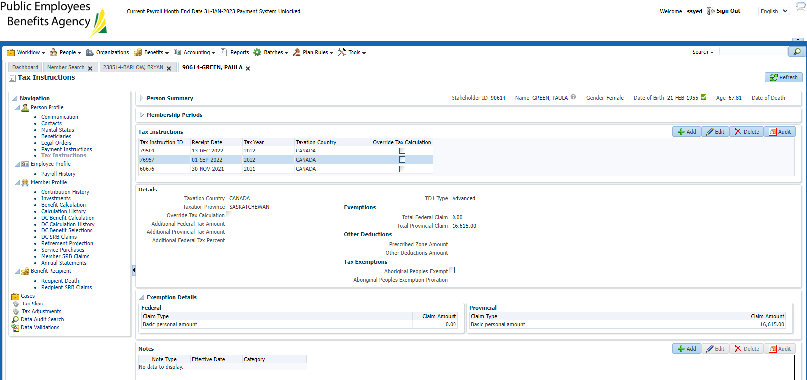

After:



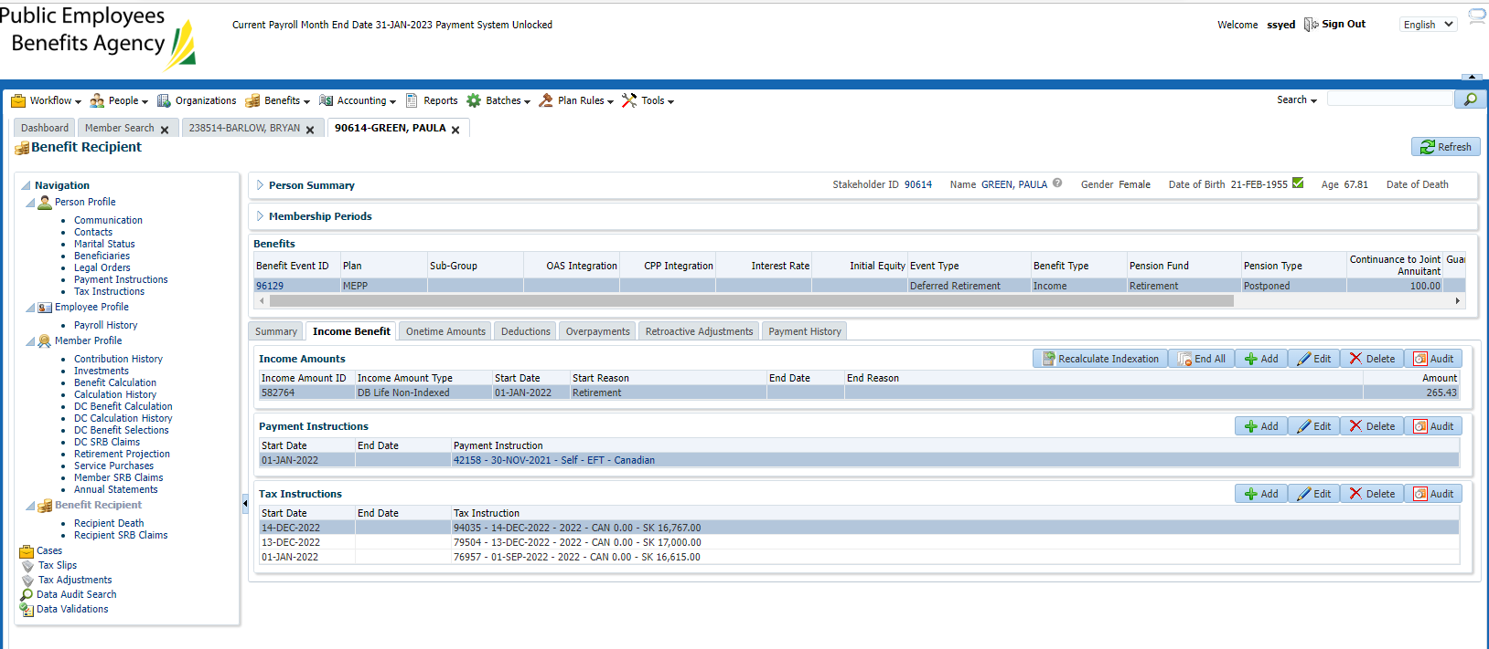

SID: 254136- additional tax

Before

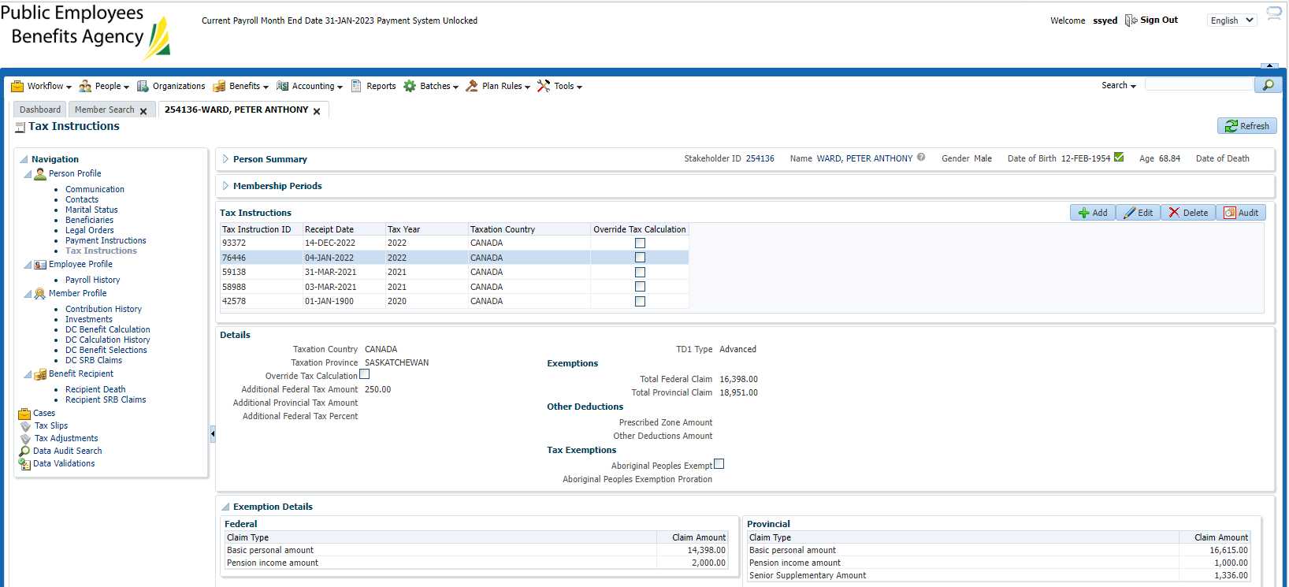

After:

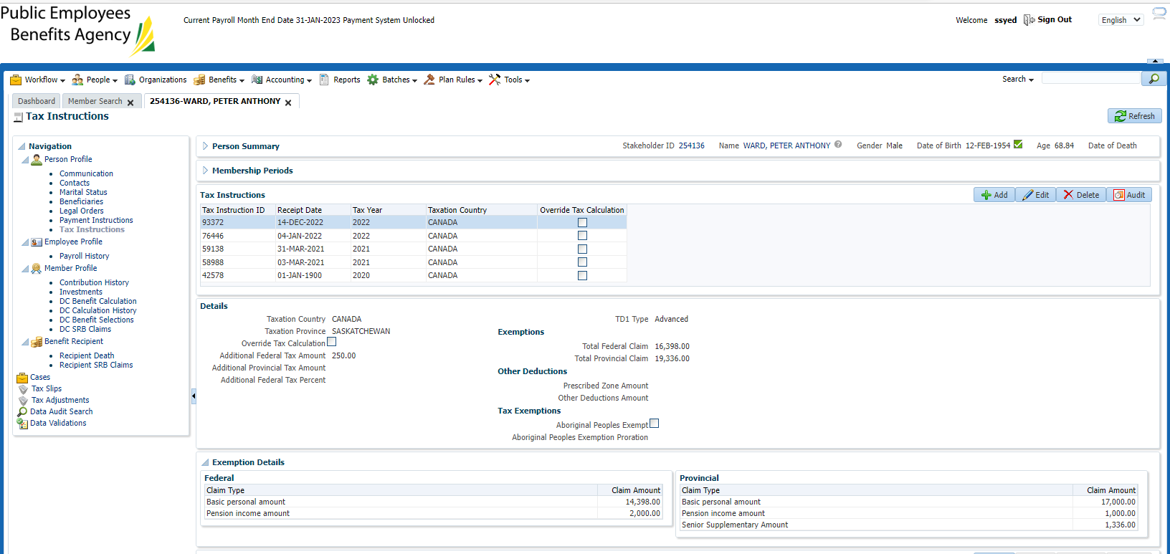

Benefit Recipient:

*\*checked to make sure there isn’t more than one plan.*

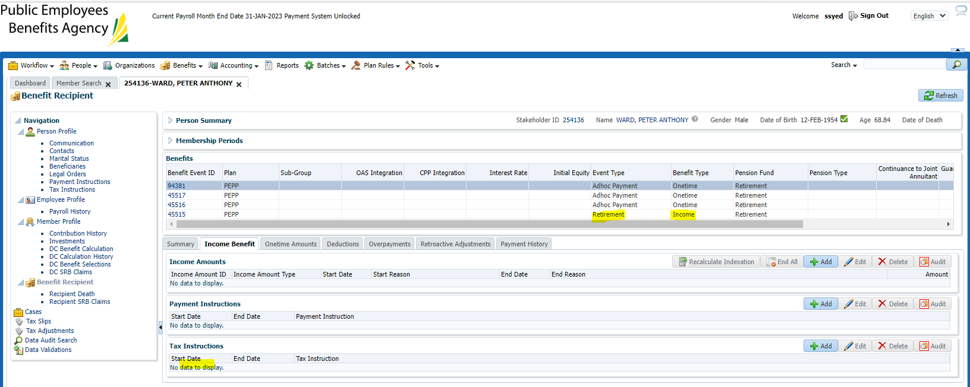

SID: 257976

Before:

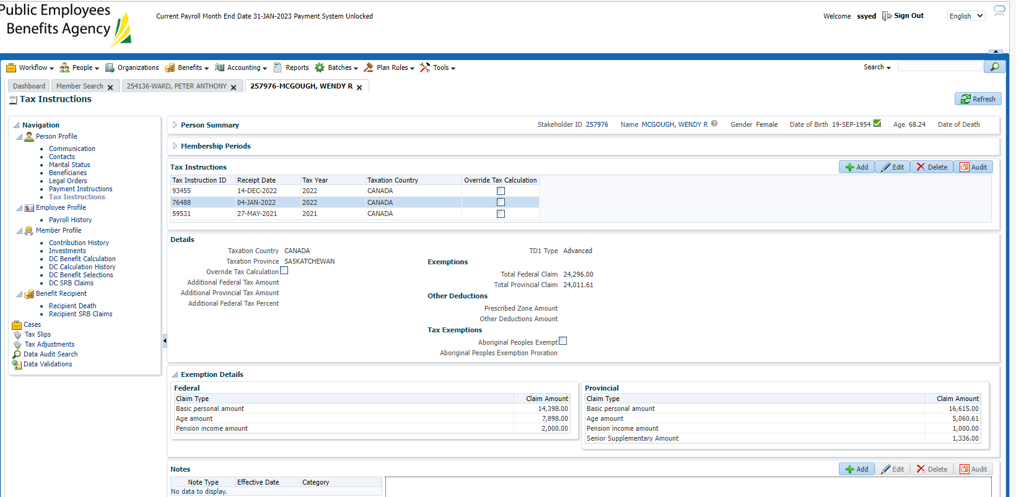

After:

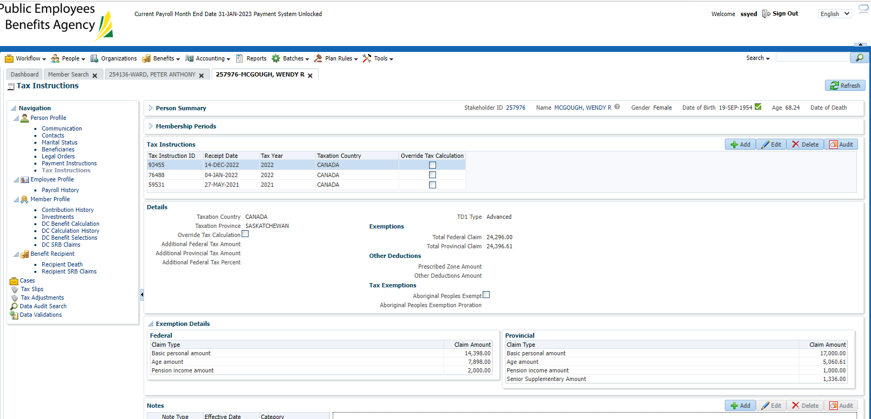

Benefit Recipient:

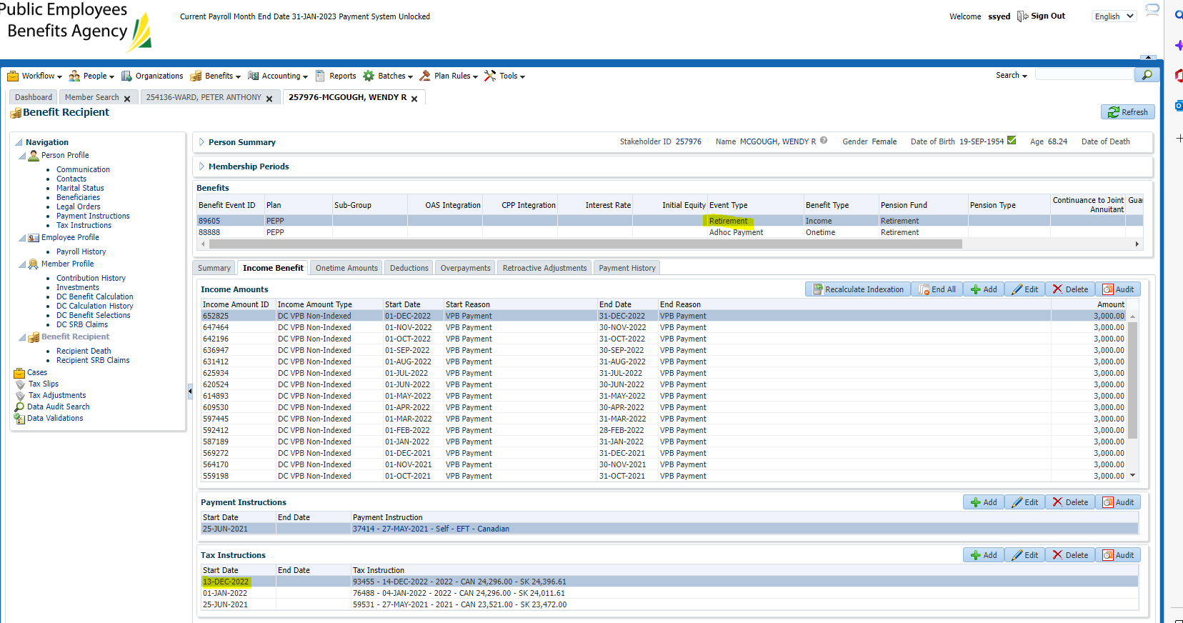

**23.04b**

SID – 197694 (more than one plan)

Before:

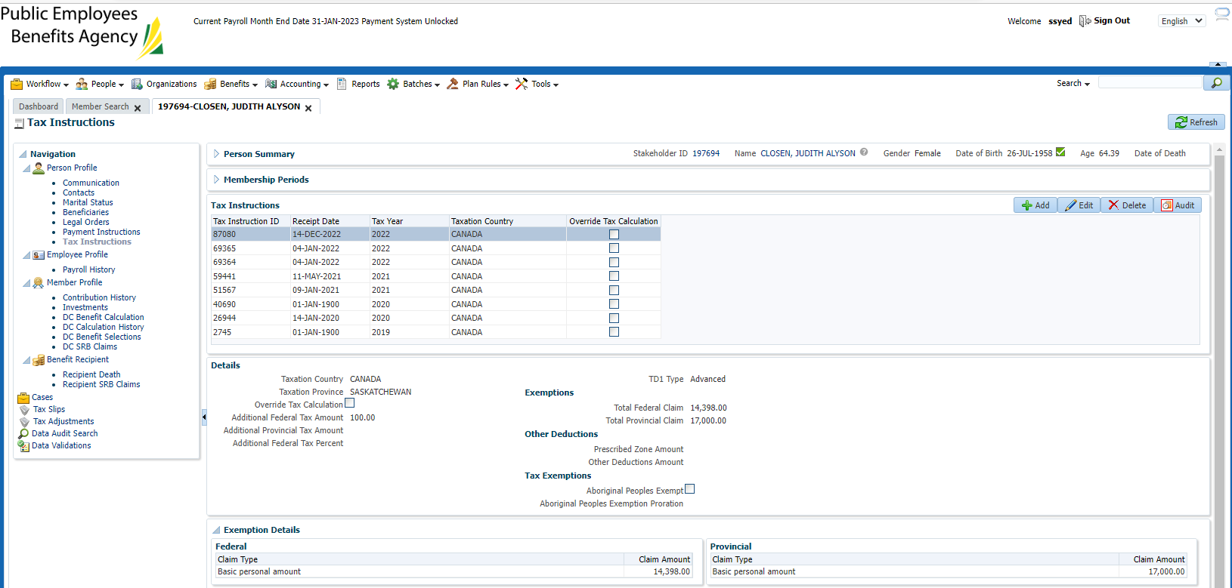

After:

*only one tax instruction created?



Benefit Recipient;

PSSP

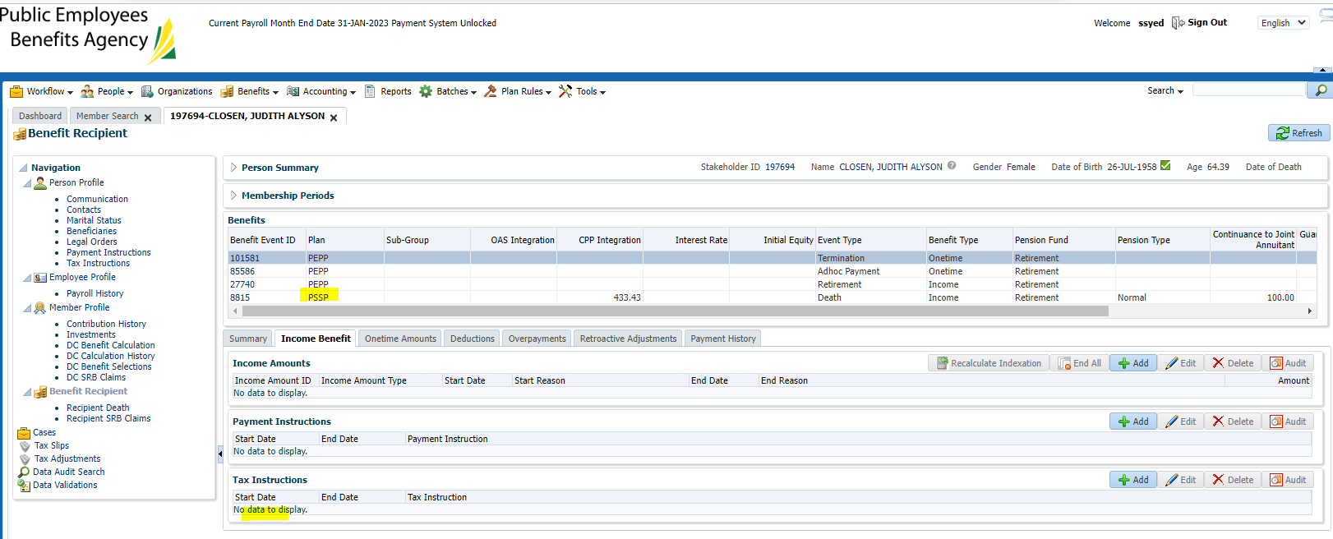

No new tax instruction created – FAIL

PEPP:

Tax instruction didn’t update as the balance is 0

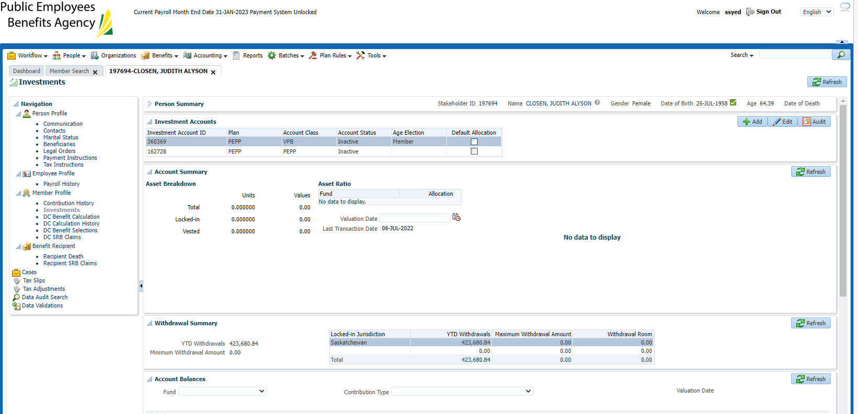

**SID: 274415**

No retirement/income benefit recipient (to find a member, check new VPB set up’s that don’t have a payment or pull report).

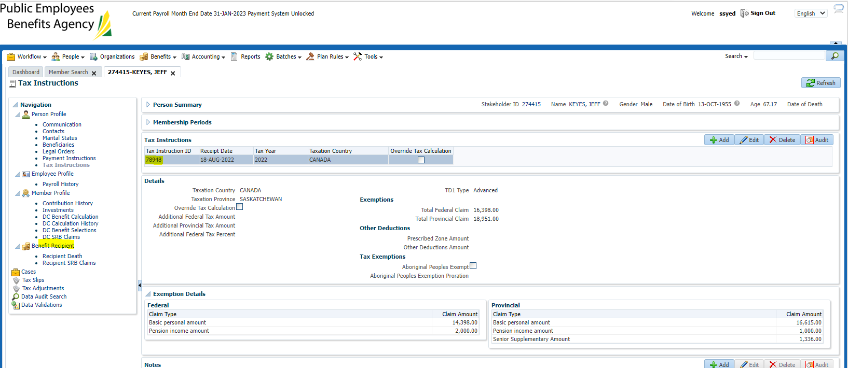

No retirement/income benefit recipient (eg. No scheduled payments have started yet but this member has taken out a lump sum payment from VPB):

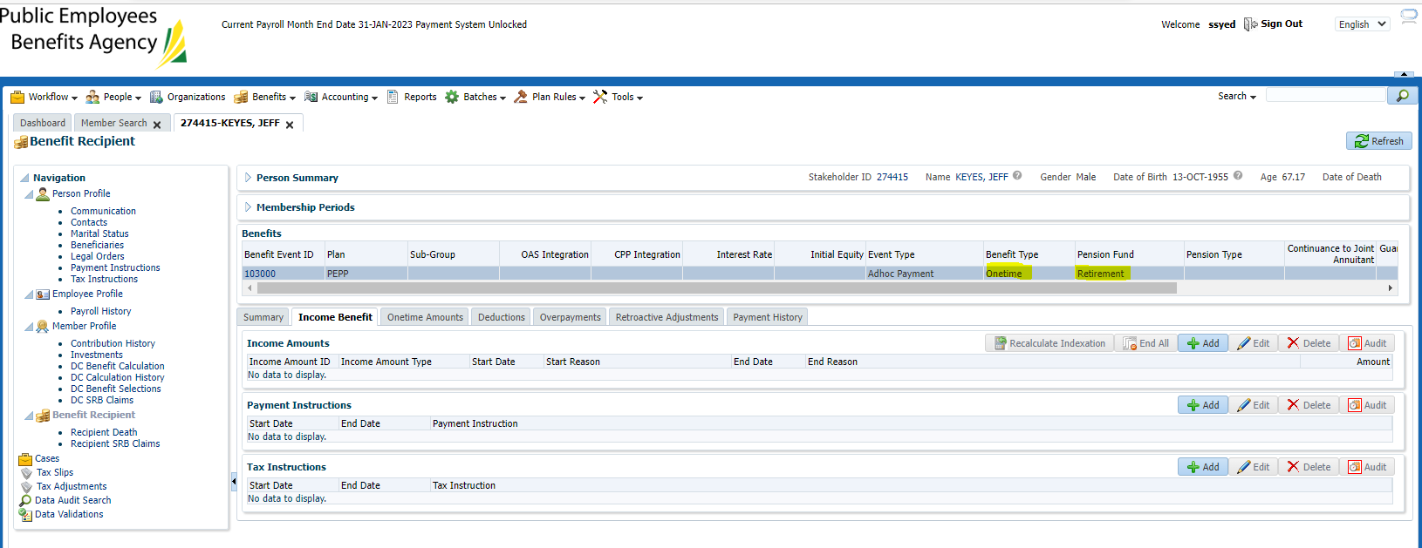

No new tax instruction created – FAIL

Checking an additional member

**SID: 243122**

Tax instruction created in Aug 2022 which is when the VPB was set up

No new Dec 13th instruction

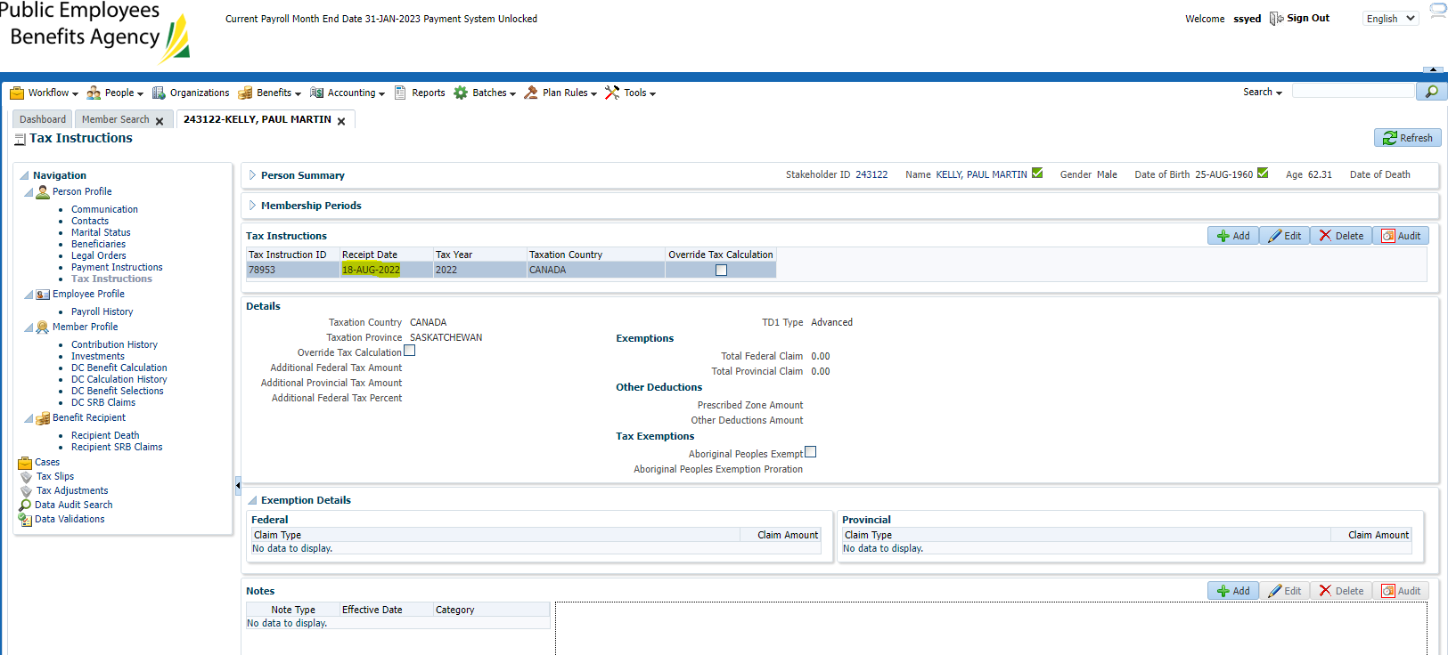

This one even has a retirement/income benefit recipient but claim code 0? Does claim code 0 need a date change in the TD1 screen in order to update – will test theory…

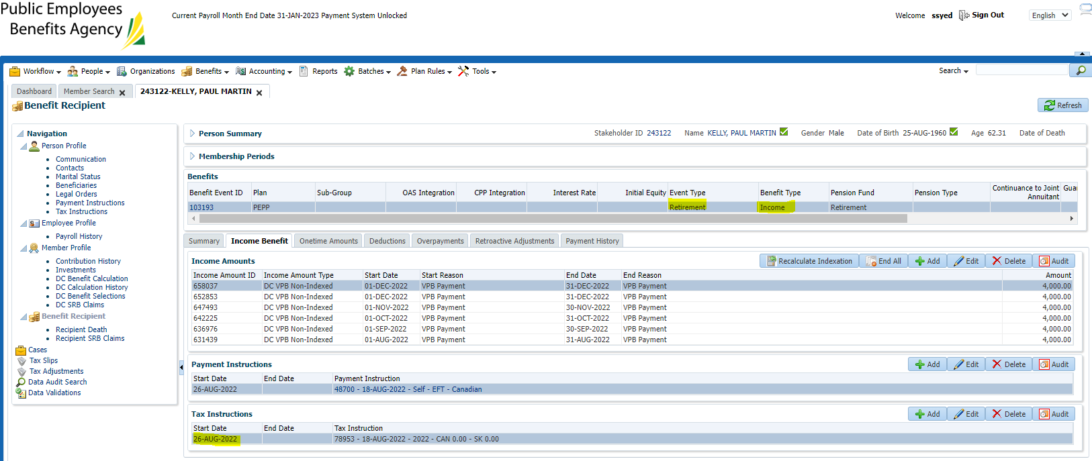

SID: 237701

Claim code 0 – tax update didn’t work??

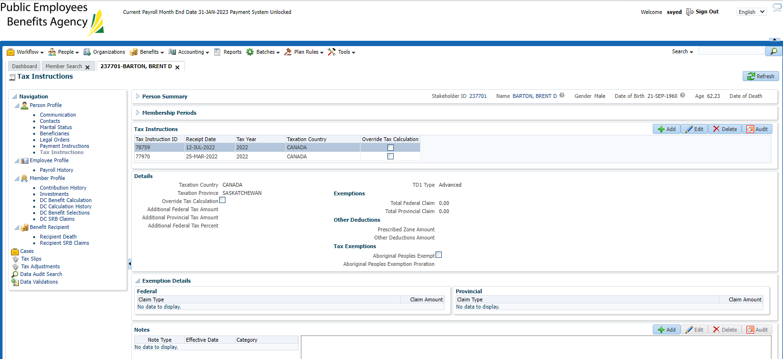

SID: 304992

Didn’t update?

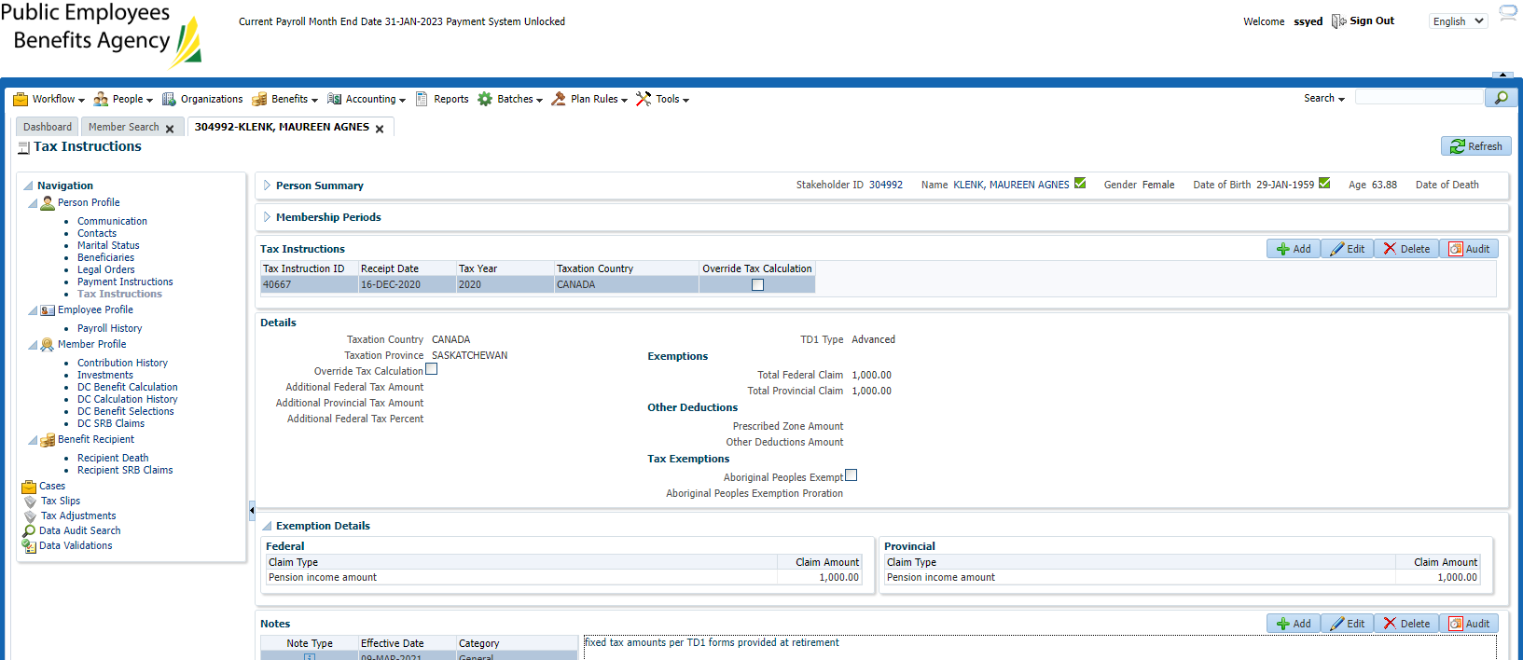

Updated Rates and re-ran tax batch:

Changed to 14.999 & 20.51110 in order to hopefully trigger the claim code 0 change

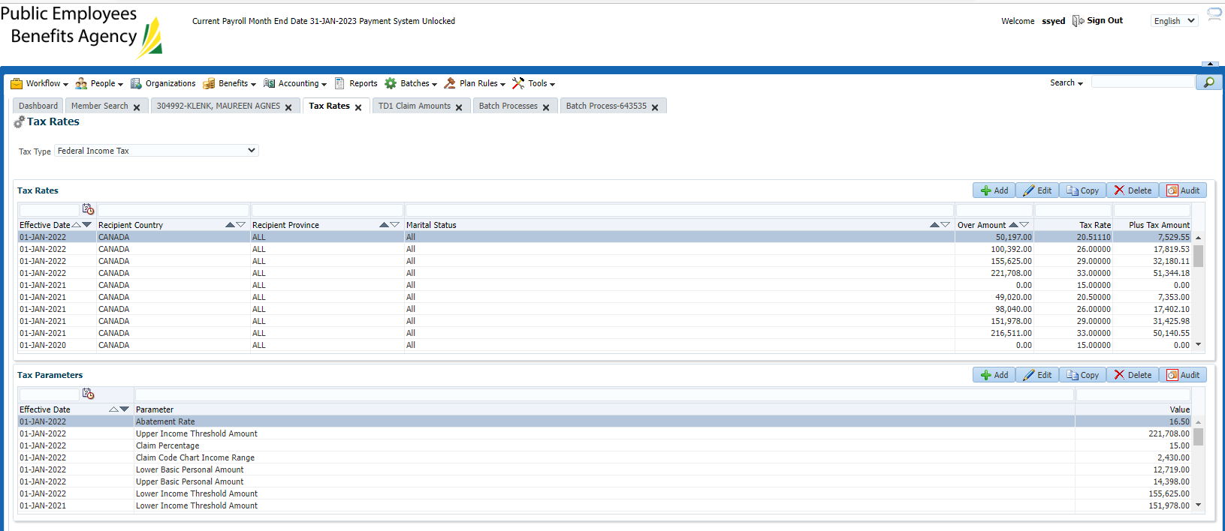

Re-stage test in Test 2:

Found same results , found no changes

JEA ticket raised- PEBA-6631 – Ready for build (current status) as of Dec 15th 2022.

Need to get fixed prior year end.